Ref: <https://youtu.be/AeUM4kR67XQ?si=bGTi-2pkWixlMs08> (more about disk partitioning)

<https://youtu.be/dMHFArkANP8?si=CG5NYBhuLhsLbLvl> (lvm)

<https://youtu.be/scMkYQxBtJ4?si=G0d36oHBmbkfuLAz> (reference vid)

<https://christitus.com/lvm-guide/>

LVM

What is an LVM? An LVM (Logical Volume Manager) is somewhat like traditional disk partitioning, however, there are some distinct differences. For example, in standard partitioning, the layers are just the hard drive and the partitions. But, in LVM, the layers include PV, VG and LV. Now, what are these terms and what do they mean? PV stands for physical volume. It means that a partition goes under that volume. Next, VG or volume group, which is a group of physical volumes. Lastly, the LV or logical volume, to a volume group is like a hard drive to a partition in standard partitioning terms. The hierarchy goes like this, Logical Volume -> Volume Group -> Physical Volume, with LV being at the top.

However, the steps to using LVM are much more complicated in the initial steps of it. This includes setting up PVs, VGs, LVs, and also deciding which partition or filesystem goes under where.

(The above is the steps we will following, starting from the bottom.)

Now, on to the task, which requires us to create a large file system that spans 2 hard disks.

Steps

The list of steps is summarised as shown below:

1. Add new disk
2. Create partitions
3. Create physical volume
4. Add the physical volume to a created volume group
5. Allocate space from volume group to logical volume
6. Resize
7. Firstly, scan your disk to check for LVM. (as this was from previous work, there are some physical volumes as shown below)A screenshot of a computer

   Description automatically generated
8. We will be using the second disk with the 1 partition on it to add the space to a logical volume. And as shown below, there is 700 mb of space available to be added.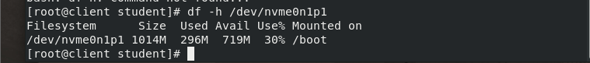
9. Now we will check for physical volume 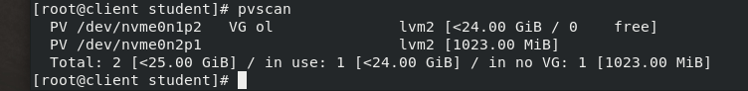

As shown in the screenshot above, it shows that we already have a physical volume for /dev/nvme0n2p1 but no volume group yet. So, we will create a volume group to add the physical volume to it.

1. But before creating a volume group, lets see the current ones.
2. Now we will add the pv to this vg or if you want, you can add another vg that you want and add this current pv to that new vg. In this case, we will be using the vg we have on the device, which is ol.This shows that the pv has successfully been added to the vg.
3. The command below shows the vg size and the available 1gb space to be added to a logical volume.A computer screen with white text and blue line

   Description automatically generated
4. Next, we will do a lv scan of available lv to add space to.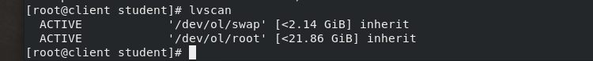
5. We will be adding it to the root volume in this case as an example as besides these two lvs, theres no other lv. And if we do want to add a new lv, we could with the lvcreate command but we won’t.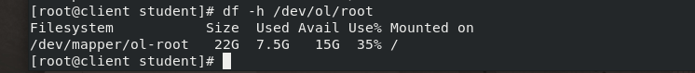

(The command above shows the available space for the root volume)

1. Next, we will add the free space to the logical volume using the command below.

(This will still still not add the free space yet as we still need to resize the file system)

1. To resize, you will type the command below. It may be different for different files as all use different filesystems, including ext or xfs. In this case, the filesystem is using xfs.A screenshot of a computer

   Description automatically generated
2. And as you can see, the filesystem has been resized and the available space has changed from 15 previously to 16.
3. For the video, we will be using a different VM so there will be slight differences but they follow the same steps.